Step 1:

→ Open the remote machine by the given user name and password.

Step 2:

→ Open var/www directory then see the list of files/folder present in the directory, see the image below

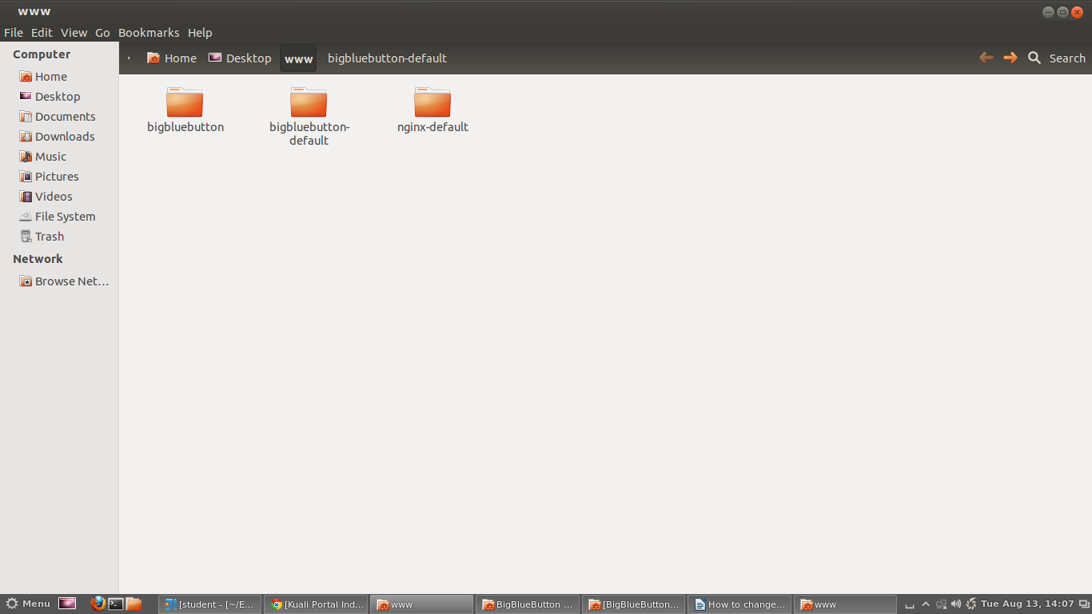

Step 3:
Open bigbluebutton-default folder. See the image below for files/folder structure

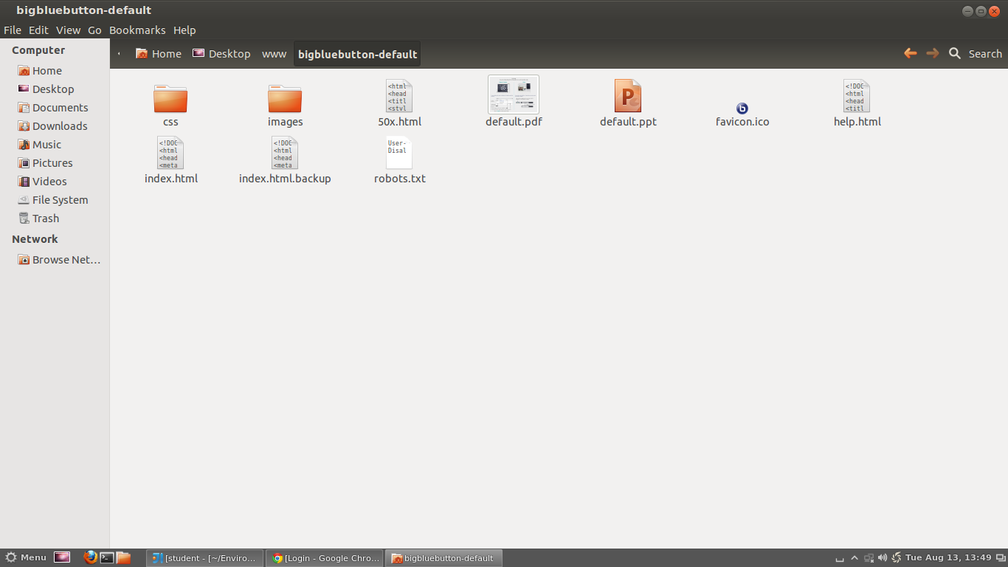

Step 4:

→ please copy your logo_image and paste inside images folder.

Step 5:

→ please open index.html file, see the below image.

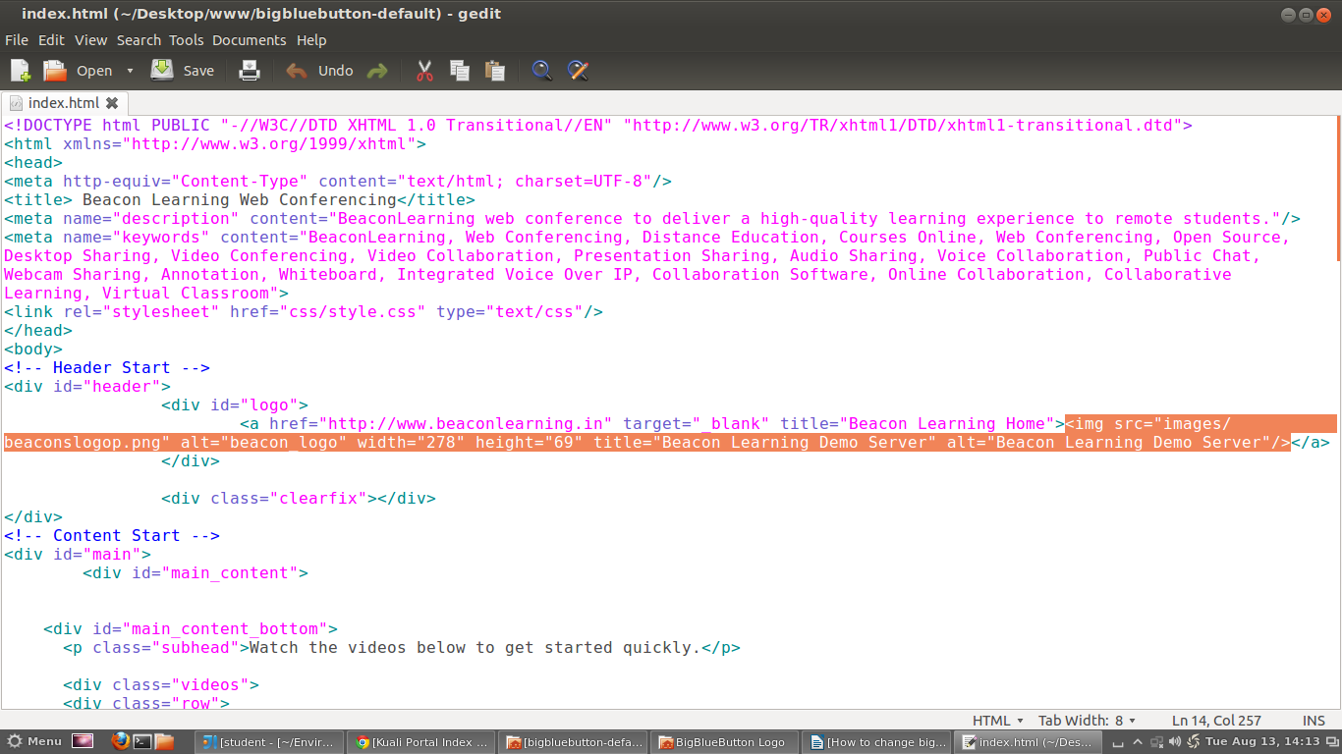

→ from the above selected area , we need to change necessary things

1) change beaconslogop.png to your <image name>

